Call for proposals
INNOVEZ - Ressourcement scientifique

Application form
(Up to 10 pages max.)

The application file must present all the elements which will allow the projects to be assessed and selected. It is limited to 10 pages maximum and must be written in ENGLISH.
It must be sent by the project leader, signed by the director of the laboratory, of the supporting establishment and accompanied by the financial annex and the table justifying the eligible amount for the project to the email address: aap-next@univ-nantes.fr
The plan below describes the various items expected in the application. We invite you to check the evaluation criteria in the specifications in order to highlight the most relevant elements. Any additional information may be added if necessary for a proper understanding of the project.
Please respect the following format for the file name and subject of the email: INNOVEZ_RESS_NOMPROJET

Project’s identity

Project
Title and acronym
Keywords (max 5)
Leader
Name, position and employer*
Contact details (email and tel)
Research unit
Legal entity in charge of administrative management
Name of the entity
Name and contact details of the person responsible for administrative management of the project
* The legal entity must be a member or a partner of the NExT Initiative.


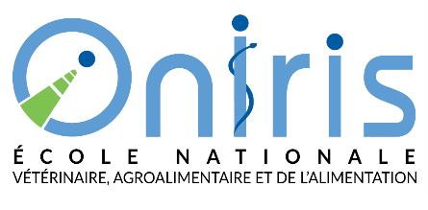




Abstract (non confidential)
Les partenaires de l’I-site
Please do not exceed 1/2 page

Project description
Les partenaires de l’I-site

  - Project concept and objectives
Present and explain the project ambition and objectives, highlight the scientific obstacles to be overcome, the innovative character and originality of the project and elements of differentiation compared to the state of the art.
Present the project team and specify the contribution of each academic and/or socio-economic partner.

  - Expected results and prospects for valorization
Explain the expected results, the project contribution for the team or the laboratory (structuring and scientific aspects), the potential of industrial deployment, the impact on the scientific excellence, the national and international visibility and notoriety of the Nantes ecosystem,…
Describe how the project will contribute to the NExT strategic scientific axes.

  - Project management
Specify the different stages of the project, methodology and organization (work-packages, calendar…), expected deliverables and success indicators.

Justification of the budget and requested grant
Les partenaires de l’I-site
Present and justify the funding request and complete the attached financial annex.

Bibliography

Annex 1 : Visas

Visa of the unit director
Detailed opinion from the project leader's unit or department management director on the feasibility of the project, its level of priority, its impact on the development of the laboratory(ies).

Nom : ___________________________________________________________________________

Unit/department : _________________________________________________________________

Date :

Visa :

Visa of the administrative and financial institution
Date :
Visa :

Annex 2: Proposal of experts

Please indicate the contacts (name and e-mail) of 10 researchers (outside the Pays de la Loire) able to review your project without conflicts of interest (no joint publication, no thesis co-direction, no young researcher/supervisor relationship, no joint project at least in the last 5 years).
If applicable, indicate the experts not appropriate for the evaluation of your project (conflicts of interest)

Suggested experts (with contact information):

Experts to exclude:

